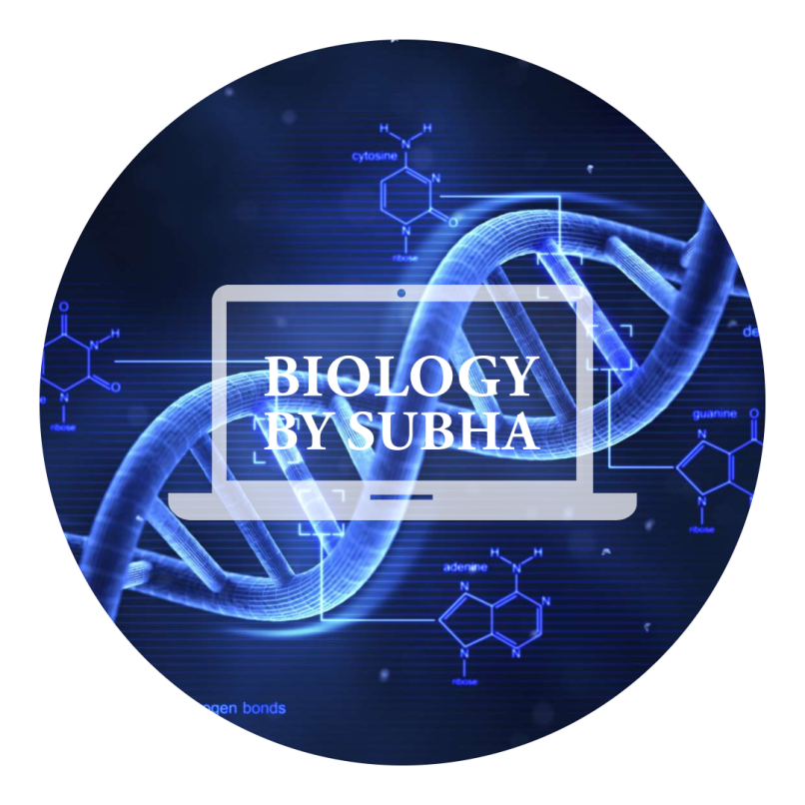

BIOMOLECULES

Topic-3: Carbohydrate Part-2

